SIMATS ENGINEERING
(Saveetha School of Engineering)
Department of Computer Science and Engineering
Software Requirement Specification (SRS)
Intelligent Disaster Early Warning and Evacuation Management System
CO2 Assessment Tool 1 — Scenario-Based Requirement Analysis
Course Code: CSA10 | Course Title: Software Engineering
CO Assessed: CO2 | Weightage: 20% | Total Marks: 25
Student Name | G.Pradeep Ranga Reddy
Reg. No. | 192311289
Date | 14-08-2026
Duration | 60 minutes
Code of Conduct
I G.Pradeep Ranga Reddy _192311289 (Name / Reg. No.) certify that this submission is my original work and that I have adhered to the guidelines specified for this assessment. I understand that any violation of academic integrity rules will result in disciplinary action.
Signature of the Student: __________ 

1. Introduction and Scenario Analysis

1.1 Purpose
This Software Requirement Specification (SRS) document describes the functional and non-functional requirements of the Intelligent Disaster Early Warning and Evacuation Management System (IDEWEMS). The purpose of the system is to detect, predict, and communicate impending natural or man-made disasters (floods, cyclones, earthquakes, tsunamis, landslides, industrial accidents, and fires) to at-risk populations in real time, and to coordinate an efficient, safe evacuation of citizens to designated shelters.

1.2 Business Domain
The system operates in the Public Safety and Disaster Management domain, intersecting with government emergency response agencies, meteorological and seismic monitoring bodies, telecommunication providers, and local municipal administration. It is a mission-critical, life-safety software system where correctness, timeliness, and availability directly influence human life and property.

1.3 Problem Description
Regions prone to natural disasters currently rely on fragmented, manually operated warning mechanisms — siren networks, television/radio bulletins, and door-to-door announcements — that are slow, geographically limited, and difficult to scale during simultaneous multi-location emergencies. Citizens frequently receive warnings too late, evacuation routes are not communicated dynamically (so people are directed into roads that are already flooded or blocked), shelters are not tracked for real-time occupancy, and disaster response authorities lack a unified dashboard to monitor sensor data, dispatch resources, and coordinate relief. There is no single platform that integrates sensor-based early detection, automated multi-channel alerting, dynamic evacuation routing, and post-disaster reporting.

1.4 System Objectives
- Continuously ingest data from weather, seismic, and hydrological sensor networks to detect early indicators of a disaster.
- Automatically classify risk level and trigger multi-channel alerts (SMS, push notification, app, siren integration, email) to citizens and authorities within a defined time threshold.
- Provide citizens with real-time, dynamically recalculated evacuation routes and nearest-shelter guidance based on live hazard zones.
- Enable field officers and volunteers to report ground-level incidents and update shelter/resource status.
- Give disaster management authorities a centralized command dashboard to monitor the situation, dispatch rescue teams, and manage relief resources.
- Maintain an auditable historical record of disaster events for post-incident analysis and future preparedness planning.

1.5 Stakeholders
Stakeholder | Role | Interest / Concern
Citizen / Public | Registers on the system, receives alerts, views evacuation routes | Timely, accurate warnings; clear evacuation guidance
Field Officer / Volunteer | Ground personnel reporting incidents, assisting evacuation | Real-time incident logging; task coordination
Disaster Management Authority (Admin) | Issues alerts, monitors dashboard, coordinates response | Situational awareness; resource allocation; accountability
System Administrator | Manages users, system configuration, uptime | System reliability, security, and maintainability
Local Emergency Services (Police / Fire / Medical) | Receives dispatch requests, executes rescue operations | Accurate location data; fast dispatch workflow
Meteorological / Seismic Agencies | Supplies sensor and forecast data feeds | Reliable data integration; correct attribution
Telecom / SMS Gateway Provider | Delivers SMS/broadcast alerts | API stability; message throughput during peak load
Local Government Bodies | Policy oversight, funding, shelter infrastructure | Compliance, cost-effectiveness, public accountability

1.6 Existing Challenges
- Delayed manual dissemination of warnings leads to inadequate evacuation time.
- No centralized, real-time view of hazard zones, shelter occupancy, or resource availability.
- Evacuation routes are static and do not adapt to changing hazard conditions (e.g., flooded roads).
- Difficulty coordinating between multiple agencies (police, fire, medical, volunteers) during large-scale events.
- Lack of a reliable mechanism for citizens to request help or report their location during an emergency.
- No structured historical data for post-disaster analysis and future risk modelling.

2. Scope of the System
IDEWEMS is a web- and mobile-accessible platform comprising four principal subsystems: (a) a Sensor Data Ingestion and Risk Analysis Engine that consumes real-time feeds from weather, seismic, and hydrological sensors and applies threshold/ML-based rules to classify risk; (b) a Multi-Channel Alert and Notification Engine that pushes warnings via SMS, mobile push notification, email, and integration hooks for public siren systems; (c) a Citizen Mobile/Web Application providing registration, live alerts, dynamic evacuation route guidance, nearest-shelter lookup, and an SOS/help-request feature; and (d) an Authority Command Dashboard for monitoring, alert issuance, resource and shelter management, rescue-team dispatch, and post-disaster reporting.
The system will integrate with external GIS/mapping services for route computation, third-party SMS/broadcast gateways for message delivery, and existing government sensor networks via standard APIs. Out of scope for this phase: autonomous drone-based search-and-rescue operations, direct control of physical siren hardware (only trigger signalling is in scope), insurance-claim processing, and long-term disaster-relief fund disbursement, all of which may be considered in future iterations.

3. Functional Requirements

3.1 Citizen / Public User Requirements
ID | Requirement | Priority
FR-01 | The system shall allow a citizen to register and log in using mobile number/email and OTP-based authentication. | High
FR-02 | The system shall send real-time disaster alerts (type, severity, affected area, recommended action) to registered citizens in the hazard zone. | High
FR-03 | The system shall display a dynamically computed evacuation route from the citizen's current location to the nearest safe shelter, avoiding hazard zones. | High
FR-04 | The system shall allow a citizen to view live shelter information including location, capacity, and current occupancy. | Medium
FR-05 | The system shall provide an SOS/help-request feature that transmits the citizen's GPS location and situation details to the nearest response team. | High
FR-06 | The system shall allow citizens to mark themselves and family members as "safe" after evacuation, visible to authorized relatives. | Medium
FR-07 | The system shall support multilingual alert content based on the citizen's registered regional language. | Medium

3.2 Field Officer / Volunteer Requirements

ID | Requirement | Priority
FR-08 | The system shall allow field officers/volunteers to log incident reports with photos, description, and GPS coordinates. | High
FR-09 | The system shall allow field officers to update shelter occupancy and resource stock (food, water, medical kits) in real time. | Medium
FR-10 | The system shall allow field officers to receive task assignments from the authority dashboard. | Medium

3.3 Disaster Management Authority Requirements

ID | Requirement | Priority
FR-11 | The system shall ingest and continuously monitor live data feeds from weather, seismic, and hydrological sensors. | High
FR-12 | The system shall automatically classify risk severity (Low / Moderate / High / Severe) based on configurable threshold rules. | High
FR-13 | The system shall allow an authorized authority user to review, edit, and approve an alert before/at the moment of broadcast, or configure fully automatic broadcast for Severe classification. | High
FR-14 | The system shall broadcast approved alerts simultaneously through SMS, push notification, email, and a public API/webhook usable by siren-trigger hardware. | High
FR-15 | The system shall provide a real-time command dashboard showing active hazard zones, shelter status, dispatched teams, and incoming SOS requests on a map. | High
FR-16 | The system shall allow authorities to dispatch and track rescue/response teams to specific incident or SOS locations. | High
FR-17 | The system shall allow authorities to manage (create, update, deactivate) shelter records and relief-resource inventories. | Medium
FR-18 | The system shall generate post-disaster summary reports (affected population, resources used, response time metrics, incident log) exportable as PDF/Excel. | Medium
FR-19 | The system shall maintain a complete audit trail of every alert issued, including timestamp, issuing authority, and recipient count. | Medium

3.4 System Administrator Requirements

ID | Requirement | Priority
FR-20 | The system shall allow a system administrator to create, modify, deactivate, and assign roles to user accounts. | Medium
FR-21 | The system shall allow configuration of sensor-threshold values and alert-escalation rules without requiring a code change. | Medium
FR-22 | The system shall log all administrative actions and system errors for monitoring and troubleshooting. | Low

4. Non-Functional Requirements
Category | Requirement Description
Performance | Critical (Severe-risk) alerts shall be generated and dispatched to all affected registered users within 60 seconds of risk classification. The dashboard map shall refresh live data at intervals of 10 seconds or less.
Scalability | The system shall support at least 5,00,000 concurrently registered citizen users per region and scale horizontally to handle simultaneous multi-district disaster events without service degradation.
Reliability | The alert-broadcast subsystem shall achieve 99.9% successful delivery attempts, with automatic failover across at least two independent SMS/notification gateway providers.
Availability | The core system (sensor ingestion, alerting, dashboard) shall be available 24×7 with an uptime target of 99.95%, including during regional power or network disruptions via redundant cloud hosting.
Security | All communications shall be encrypted in transit (TLS 1.2+) and sensitive data encrypted at rest. Role-based access control shall restrict alert-issuing privileges to verified authority accounts. OTP-based authentication is mandatory for citizen accounts.
Usability | The citizen-facing mobile application shall be operable by users with minimal digital literacy, support offline caching of the last known evacuation route, and comply with basic accessibility guidelines (large text, high-contrast alert screens).
Maintainability | The system shall be built on a modular, loosely coupled microservice architecture so that individual components (alerting, GIS, dashboard) can be updated independently without full-system downtime.
Interoperability | The system shall expose standard REST/webhook APIs to integrate with government sensor networks, third-party SMS gateways, and GIS mapping providers.
Data Integrity | All sensor readings, alerts, and incident reports shall be immutably logged with timestamps to support audit and post-disaster forensic analysis.
Localization | Alert content and the citizen application UI shall support configurable regional languages.

5. Actors and Use Cases

5.1 Primary Actors
- Citizen / Public User — end beneficiary who receives alerts and evacuates.
- Field Officer / Volunteer — ground-level personnel supporting response.
- Disaster Management Authority (Admin) — issues alerts and coordinates response.
- System Administrator — manages users, configuration, and platform health.

5.2 Secondary (External) Actors
- Weather / Seismic Sensor Network — supplies raw environmental data.
- SMS / Broadcast Gateway — delivers alert messages to citizens.
- Local Emergency Services — executes physical rescue and medical response.
- GIS / Mapping Service — supplies map data and route computation.

5.3 Use Case Diagram
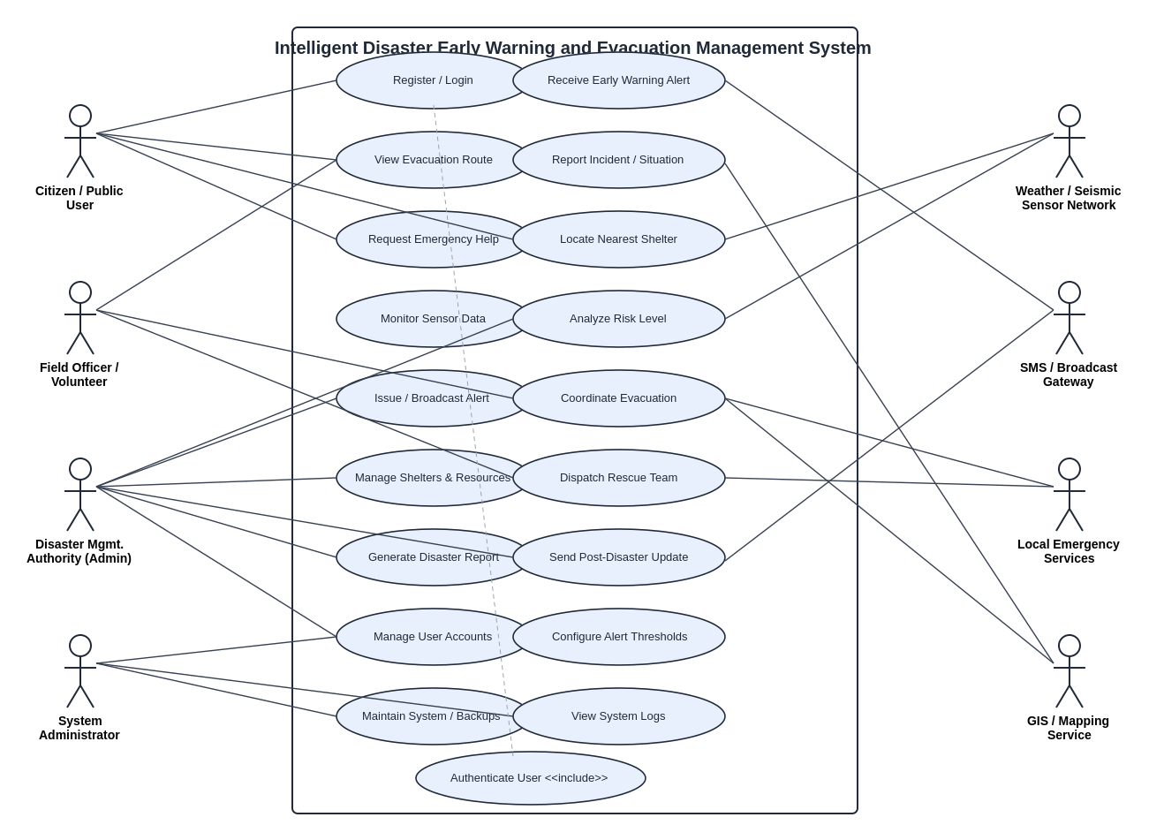
Figure 1: Use Case Diagram — Intelligent Disaster Early Warning and Evacuation Management System

6. Use Case Descriptions

UC-01: Receive Early Warning Alert
Use Case ID / Name | UC-01: Receive Early Warning Alert
Primary Actor | Citizen / Public User
Secondary Actors | SMS/Broadcast Gateway, Weather/Seismic Sensor Network
Preconditions | Citizen is registered with a valid location; risk engine has classified an active hazard.
Main Flow | 1. Sensor engine detects abnormal readings. 2. Risk analysis engine classifies severity. 3. System identifies citizens within the affected geofence. 4. Alert is broadcast via SMS, push notification, and email. 5. Citizen receives the alert with severity, instructions, and a link to the evacuation route.
Alternate Flow | If push notification delivery fails, the system falls back to SMS via a secondary gateway.
Postconditions | Citizen is informed of the hazard and next recommended action; delivery status is logged.

UC-02: View Dynamic Evacuation Route
Use Case ID / Name | UC-02: View Dynamic Evacuation Route
Primary Actor | Citizen / Public User
Secondary Actors | GIS / Mapping Service
Preconditions | Citizen has an active alert and has granted location access.
Main Flow | 1. Citizen opens the app and selects "Evacuate Now". 2. System requests current GPS location. 3. System queries the GIS service for a route avoiding marked hazard zones and leading to the nearest available shelter. 4. Route with turn-by-turn guidance and shelter capacity is displayed.
Alternate Flow | If the nearest shelter is at full capacity, the system recalculates the route to the next nearest available shelter.
Postconditions | Citizen has a safe, current route to a shelter with available capacity.

UC-03: Issue / Broadcast Alert
Use Case ID / Name | UC-03: Issue / Broadcast Alert
Primary Actor | Disaster Management Authority (Admin)
Secondary Actors | SMS/Broadcast Gateway
Preconditions | Authority account is authenticated; risk engine has generated a proposed alert.
Main Flow | 1. Authority reviews the auto-generated risk classification and affected zone on the dashboard. 2. Authority edits alert text/severity if required. 3. Authority approves and issues the alert. 4. System dispatches the alert across all configured channels and logs the action.
Alternate Flow | For a Severe classification with auto-broadcast enabled, the system issues the alert immediately without waiting for manual approval, and notifies the authority after the fact.
Postconditions | Alert is delivered to all citizens/officers in the affected zone; audit record is created.

UC-04: Request Emergency Assistance (SOS)
Use Case ID / Name | UC-04: Request Emergency Assistance (SOS)
Primary Actor | Citizen / Public User
Secondary Actors | Local Emergency Services, Field Officer/Volunteer
Preconditions | Citizen app has location permission enabled.
Main Flow | 1. Citizen taps the SOS button. 2. App captures GPS coordinates and optional situation description. 3. Request is transmitted to the authority dashboard and nearest field officer. 4. Authority dispatches a rescue team and tracks status until resolved.
Alternate Flow | If GPS is unavailable, the citizen may manually enter their last known location.
Postconditions | A rescue task is created and tracked to completion; citizen receives status updates.

UC-05: Monitor Sensor Data and Classify Risk
Use Case ID / Name | UC-05: Monitor Sensor Data and Classify Risk
Primary Actor | Disaster Management Authority (Admin) (system-assisted)
Secondary Actors | Weather/Seismic Sensor Network
Preconditions | Sensor feeds are connected and reporting.
Main Flow | 1. System continuously polls/streams sensor data. 2. Data is validated and normalized. 3. Threshold/ML rules classify current risk level per zone. 4. Dashboard updates the live hazard map; if risk crosses a critical threshold, an alert proposal is generated automatically.
Alternate Flow | If a sensor feed goes offline, the system flags the affected zone as "data-stale" and notifies the administrator.
Postconditions | Current, validated risk levels are available to all downstream alerting and dashboard functions.

7. Data Requirements
The system shall maintain the following principal data entities:
- User Profile: user ID, name, contact number, email, registered address/geolocation, language preference, role (citizen/officer/admin), family/dependent links.
- Sensor Reading: sensor ID, type (rainfall, seismic, water-level, wind-speed), timestamp, value, unit, geolocation, data-quality flag.
- Alert Record: alert ID, hazard type, severity level, affected geofence, issuing authority, timestamp, channels used, delivery status, acknowledgement count.
- Shelter Record: shelter ID, name, location, total capacity, current occupancy, available resources (food, water, medical), contact officer.
- Incident Report: report ID, reporter ID, description, photo/media reference, geolocation, timestamp, status (open/in-progress/resolved).
- SOS Request: request ID, citizen ID, geolocation, timestamp, description, assigned responder, resolution status.
- Audit Log: action ID, actor, action type, target entity, timestamp.
All personally identifiable data (contact numbers, addresses, family links) shall be stored in encrypted form and accessed only by authorized roles, in compliance with applicable data-protection regulations. Sensor and alert data shall be retained for a minimum of five years to support disaster-preparedness research.

8. External Interface Requirements

8.1 User Interfaces
- Citizen Mobile Application (Android/iOS) and a responsive Web Portal — simplified, high-contrast alert screens; multilingual UI; offline-cached evacuation route view.
- Authority Command Dashboard (Web) — live map view, alert-management console, shelter/resource management panel, reporting module.

8.2 Hardware Interfaces
- Integration endpoints for IoT-based weather, seismic, and water-level sensor hardware via standard protocols (MQTT/REST).
- Optional trigger signal output to physical public-siren control units.

8.3 Software Interfaces
- REST/webhook APIs to third-party SMS and push-notification gateways.
- GIS/Mapping Service API for geocoding, hazard-zone overlay, and route computation.
- Integration with government/meteorological department data feeds (e.g., IMD-type APIs).

8.4 Communication Interfaces
- HTTPS/TLS-secured REST APIs for all client-server communication.
- Push notification services (e.g., FCM/APNs equivalent) for real-time mobile alerts.
- SMS/USSD channel for citizens without smartphone/internet access.

9. System Features
Feature | Description / Value
Early Warning Engine | Ingests multi-source sensor data and classifies disaster risk automatically, minimizing human reaction delay.
Multi-Channel Alerting | Ensures alert reach across SMS, push, email, and siren-trigger channels so no citizen segment is left uninformed.
Dynamic Evacuation Guidance | Recomputes safe routes in real time as hazard zones and shelter capacities change.
Command Dashboard | Gives authorities a single live operational picture combining hazards, shelters, incidents, and dispatched teams.
SOS & Rescue Dispatch | Closes the loop between a citizen in danger and the nearest available responder.
Reporting & Analytics | Converts operational data into structured post-disaster reports for accountability and future planning.

10. Assumptions and Constraints

10.1 Assumptions
- Citizens in target regions have access to at least a basic mobile phone capable of receiving SMS.
- Government/meteorological sensor networks expose data through accessible, sufficiently reliable APIs.
- Third-party SMS and push-notification gateways can meet the required message-delivery throughput during peak load.
- Local authorities will designate and maintain accurate shelter-capacity data.
- Internet/cellular network infrastructure remains at least partially operational during most disaster scenarios (with SMS/USSD as fallback).

10.2 Constraints
- Technical: Dependent on the accuracy and uptime of third-party sensor and mapping data sources outside the project's direct control.
- Operational: Requires coordination and data-sharing agreements with government disaster-management bodies and telecom providers.
- Economic: Budget limits the number of SMS gateway partners and the extent of sensor-hardware deployment in Phase 1.
- Legal / Regulatory: Must comply with data-protection and privacy regulations for storage of citizen location and contact data, and with telecom regulations for bulk SMS broadcast.
- Time: The system must be delivered ahead of the region's seasonal disaster window (e.g., monsoon/cyclone season), constraining the development timeline.
- Environmental: Physical infrastructure (servers, sensors) must remain operational during the disaster events the system is designed to respond to, requiring redundant/cloud-hosted deployment.

11. Validation of Requirement Completeness and Consistency

11.1 Stakeholder Coverage Check
Each stakeholder identified in Section 1.5 has at least one corresponding functional requirement and use case: citizens (FR-01–FR-07, UC-01, UC-02, UC-04), field officers (FR-08–FR-10), authorities (FR-11–FR-19, UC-03, UC-05), and system administrators (FR-20–FR-22). No stakeholder group is without a mapped requirement, confirming coverage completeness at this level of analysis.

11.2 Ambiguity, Redundancy, and Inconsistency Review
- Ambiguity: Initial drafts used vague terms such as "quickly" and "large scale" for alert delivery; these have been replaced with measurable targets (e.g., "within 60 seconds", "5,00,000 concurrent users") in the Non-Functional Requirements to remove subjectivity.
- Redundancy: FR-02 (citizen alert receipt) and FR-14 (authority alert broadcast) were checked to ensure they describe the same event from two different actor perspectives rather than duplicating a requirement — retained as complementary, not redundant.
- Inconsistency: An earlier draft allowed both fully automatic and manual-approval alert issuance without specifying precedence. This has been resolved in FR-13 by tying automatic broadcast strictly to "Severe" classification, with all lower severities requiring authority approval.
- Missing requirements identified during review and since added: multilingual alert support (FR-07), safe-status marking for families (FR-06), and sensor data-quality/stale-feed handling (UC-05 alternate flow).

11.3 Consistency with Non-Functional Requirements
Functional requirements involving alert broadcast (FR-02, FR-13, FR-14) were cross-checked against the Performance and Reliability non-functional requirements to confirm the 60-second delivery target and 99.9% delivery-success rate are technically achievable given the two-gateway failover design described in Section 8.3.

11.4 Suggested Improvements
- Introduce formal acceptance criteria (Given–When–Then format) for each functional requirement in the next iteration to further reduce interpretation ambiguity during development and testing.
- Add a requirements traceability matrix linking each FR/NFR to its originating stakeholder need, its use case, and its eventual test case.
- Conduct a structured stakeholder walkthrough / JAD session to validate assumptions in Section 10.1 before committing to the technical architecture.
- Define explicit conflict-resolution rules for cases where multiple hazard types affect the same zone simultaneously (e.g., cyclone and flood together), which is not yet covered by a distinct requirement.
- Establish measurable acceptance thresholds for usability (e.g., task-completion time for an SOS request) to make Usability NFRs independently testable, not just descriptive.

